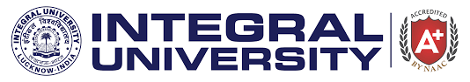

**Report**

Slogan Writing on

**“Communal Harmony and Responsible Citizenship”**

Organized by

Department of Chemistry

&

Department of Environmental Science

The Department of Chemistry in collaboration with the Department of Environmental Science organized a Slogan writing competition on the theme “**Communal Harmony and Responsible Citizenship”** on **26th August, 2023** in Academic Block D (D113) at 11:00 am onwards. Communal harmony strives to create goodwill and harmony among various communities and it is utmost necessary to understand the individual role and responsibility towards a sustainable communal harmony and to maintain a peaceful and cohesive society. **The Sustainable Development Goal (SDG 16)** also endorses and promotes peaceful and inclusive societies and talks about provision of justice for all and building effective, accountable and inclusive institutions at all levels. A total of 23 creative slogans were received which elaborated diverse ways to promote communal harmony. The activity was coordinated by Dr. Tahmeena Khan, Assistant Professor, Department of Chemistry and Dr. Amina Jafri, Assistant Professor, Department of Environmental Science. The slogans were judged by Dr. Shadab Ahmad Khan, Associate Professor, Department of Mathematics and Statistics and Dr. Mohd. Imran Ahmad, Assistant Professor, Department of Chemistry. The winners of the competition were:

**1. Iqra Salman (M.Sc. EVS, Ist year)**

**2. Ankit Kumar (M.Sc. Chemistry, Ist year)**

**3. Azmeen Khan (B.Sc. PCM, Ist year)**

**Glimpses of the event**

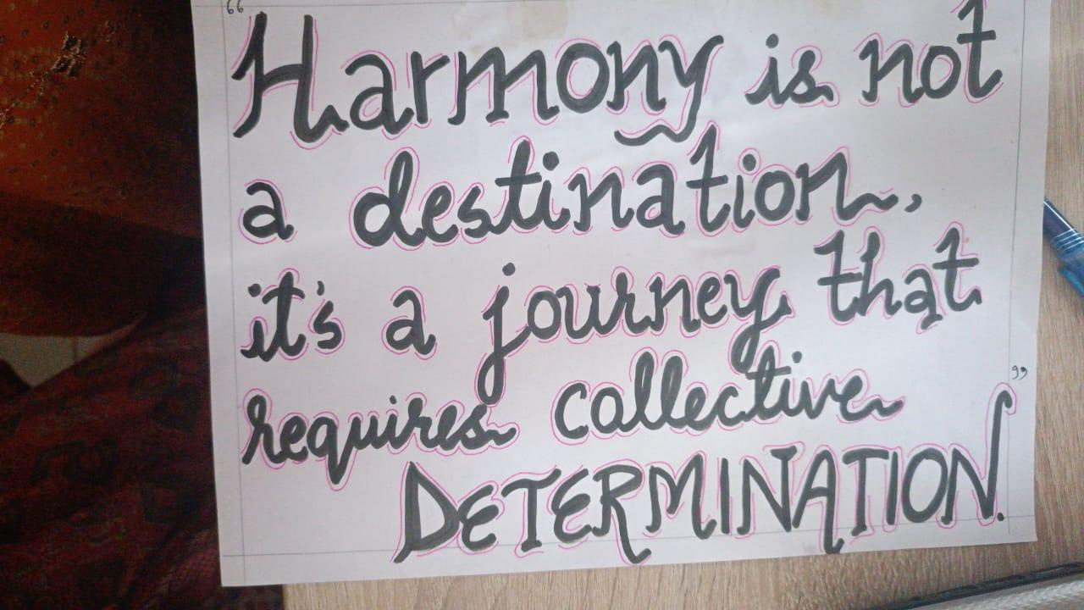 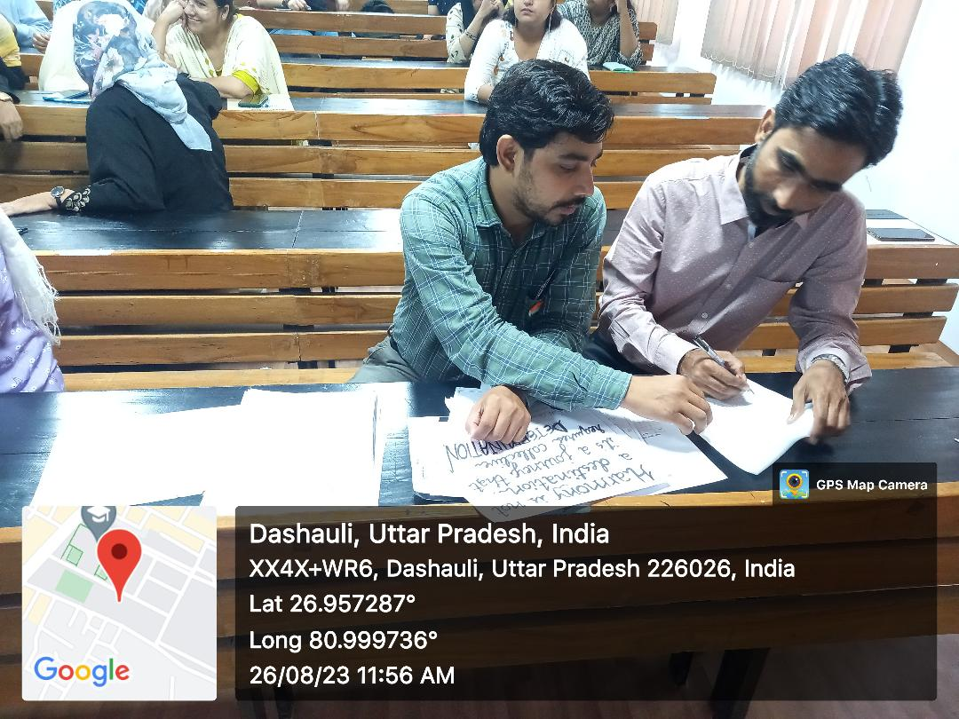

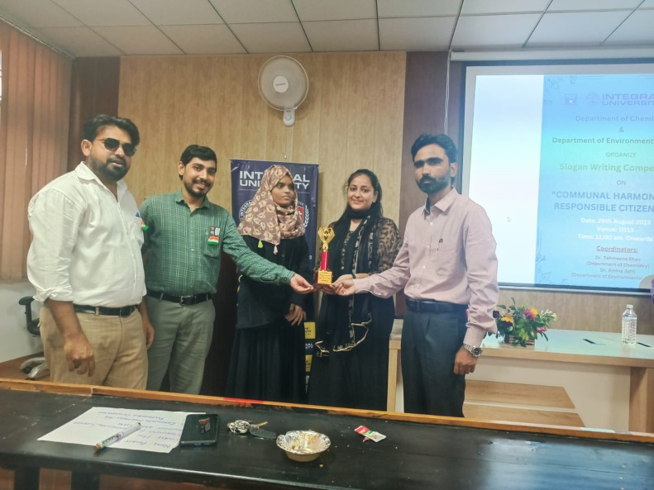 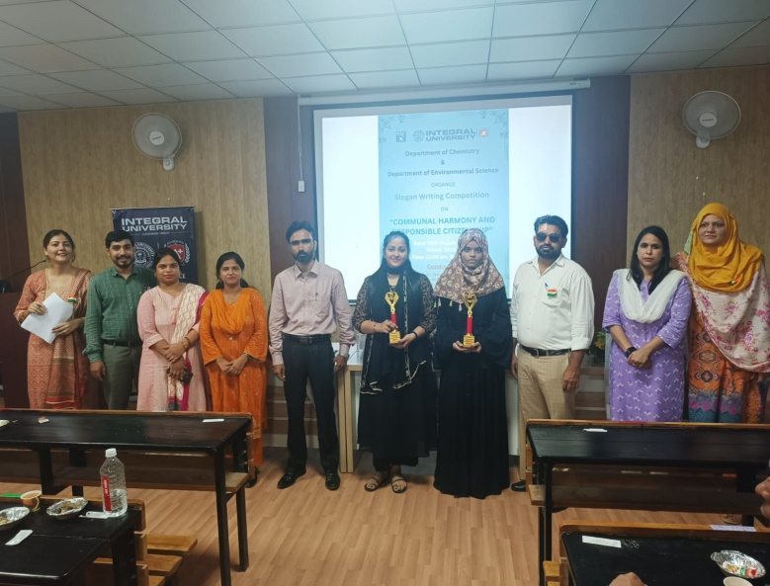

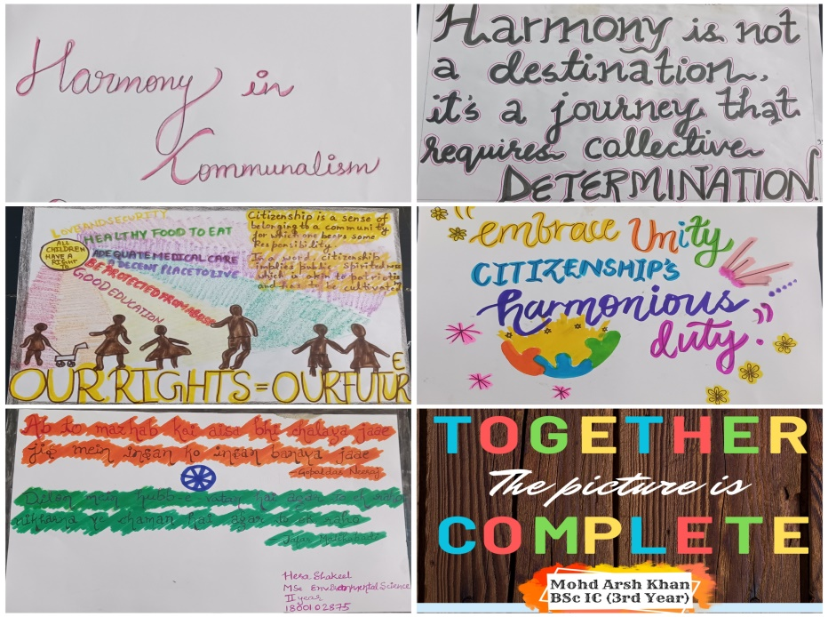

Submitted by:

Dr. Tahmeena Khan

Dr. Amina Jafri